# Setting up Unit Testing locally

Guide for installing and setting up the needed libraries and frameworks to allow local testing of JS code working with the DOM for the [“JavaScript Advanced” course @ SoftUni](https://softuni.bg/courses/javascript-advanced).

### Install

In order to test JS code easily we'll install the testing framework - **Mocha** and an assertion library to go with it - **Chai**.  
Setting up testing of the DOM requires some additional libraries - jsdom to simulate the DOM and jsdom-global a small helper library which takes care of the jsdom setup for us. We'll also install jquery for easier manipulation of the DOM.

1. Install Mocha globally, we can do it from cmd or from the Webstorm terminal (they're equivalent):

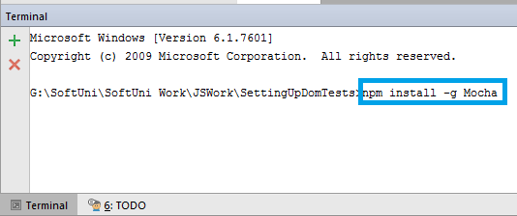

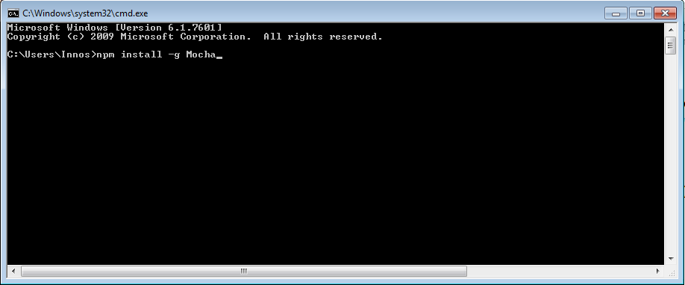

1. Install Chai globally ( the same way as above):  
   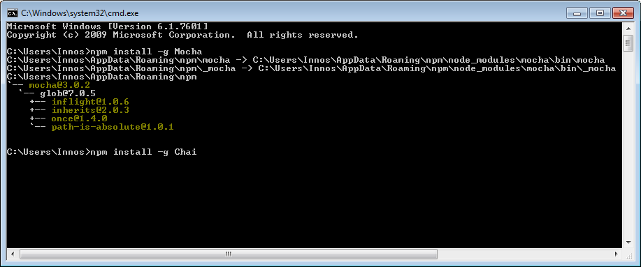
2. Install jsdom globally:  
   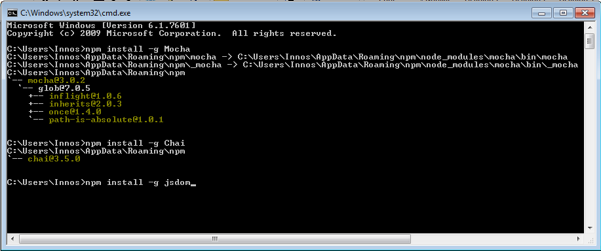
3. Install jsdom-global globally:  
   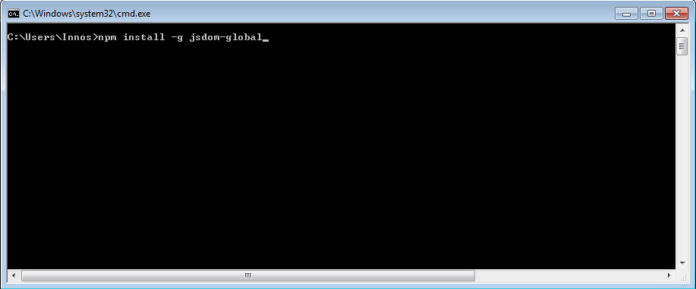
4. Install jquery globally:  
   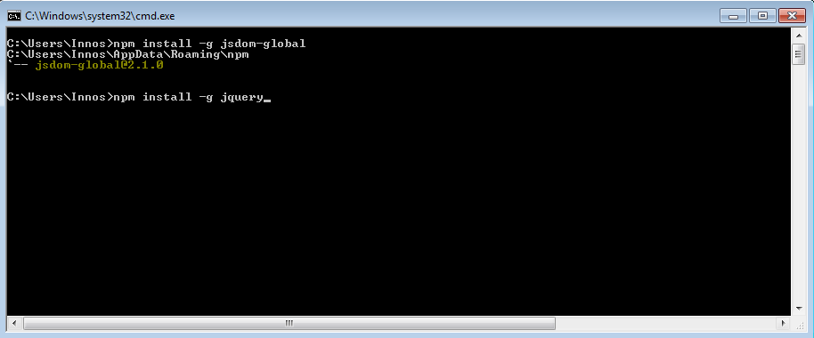

### Setup

We can setup the libraries for global use by adding a NODE_PATH variable in the registries:

setx NODE_PATH %AppData%\npm\node_modules

set NODE_PATH=%AppData%\npm\node_modules

npm install --save-dev chai

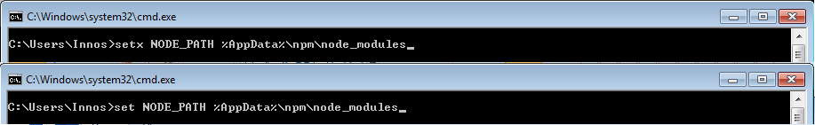

### Usage

In order to load and use a library we need to require it in the JavaScript file:

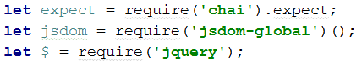

Keep in mind that **jsdom-global** requires you to have installed **jsdom** and must also be executed (thus the double brackets()). You also have to require **jquery** after the DOM has been loaded.

In order to set up the HMTL that is going to be used you can pass it as text to document.body.innerHTML as follows:

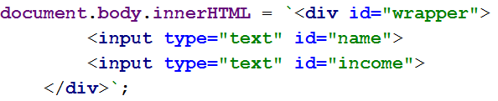

Here's an example setup:

|  |
| --- |
| example.js |
| **let** expect = require(**'chai'**).expect; **let** jsdom = require(**'jsdom-global'**)(); **let** $ = require(**'jquery'**);  **document**.**body**.**innerHTML** = **`<div id="wrapper">  <input type="text" id="name">  <input type="text" id="income">  </div>`**;  **let** *testedFunction* = **function** () {  *//Some code* };  describe(**'testedFunction'**,**function** () {  *//Tests here* }); |